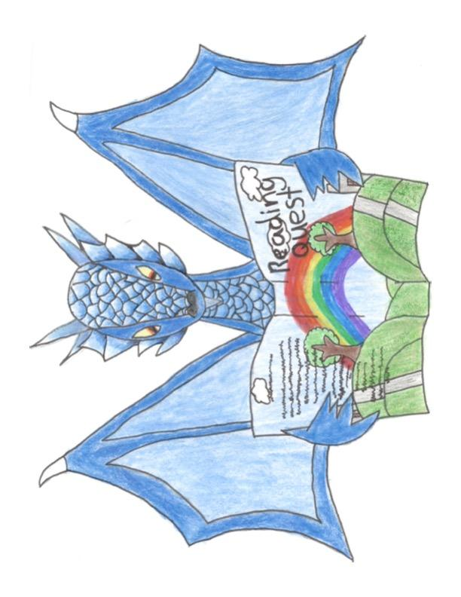Reading Quest Suggestions
Games for Small Reading Groups Online

- Reading Game Programs
- Red Apple Reading: best for K-3 reading levels- free accounts for teachers. Children can play on their own at home too.
- Book Nook: best for students who know their alphabet and cvc words: free accounts for teachers.
B. Great Apps for beginning readers to play on their own on an ipad or phone
Letter School: for students just learning their ABCs- how to write them and what sound each letter makes
Reading Raven: for beginning readers

- Games to play that include reading as a part of the game and do not require word cards.
- Natgeokids.com:
:Funny Fill ins (for parts of speech)
: Letter Predator (like HangMan)
- The Big Escape: https://www.tvokids.com/school-age/games/big-escape
: a scavenger hunt game with reading for grade level readers 3rd and up (maybe 2nd grade) This game does not need word cards.

- Games to play that work best with word cards (digital or physical)
Reading Quest has a range of word card piles available on their website: https://www.readingquestcenter.org/store.html?locale=en
- ToyTheater.com:
Under Games: chess, checkers, 4 Colors (same as Uno)
Under Puzzles: Parking, Maze
- Matchthememory.com: easily adapted for whatever topic the group is interested in (Minecraft, fortnite, horses, mermaids, unicorns) The number of matches can be changed as well.
- TicTacToe: https://www.twoplayergames.org/Giant-Tic-Tac-Toe/1691.html
- Connect Four: https://www.safekidgames.com/straight-4/
- Girlsgogames.com: a wide range of games including:
Unicorn Beauty Salon, Paws to Beauty, Cute Pup Rescue
Always check out the game before playing
- Storyboard That and Pixton: comic strip making programs

9. GUESS WHO? - Play Guess Who? on Poki

10. Google snake 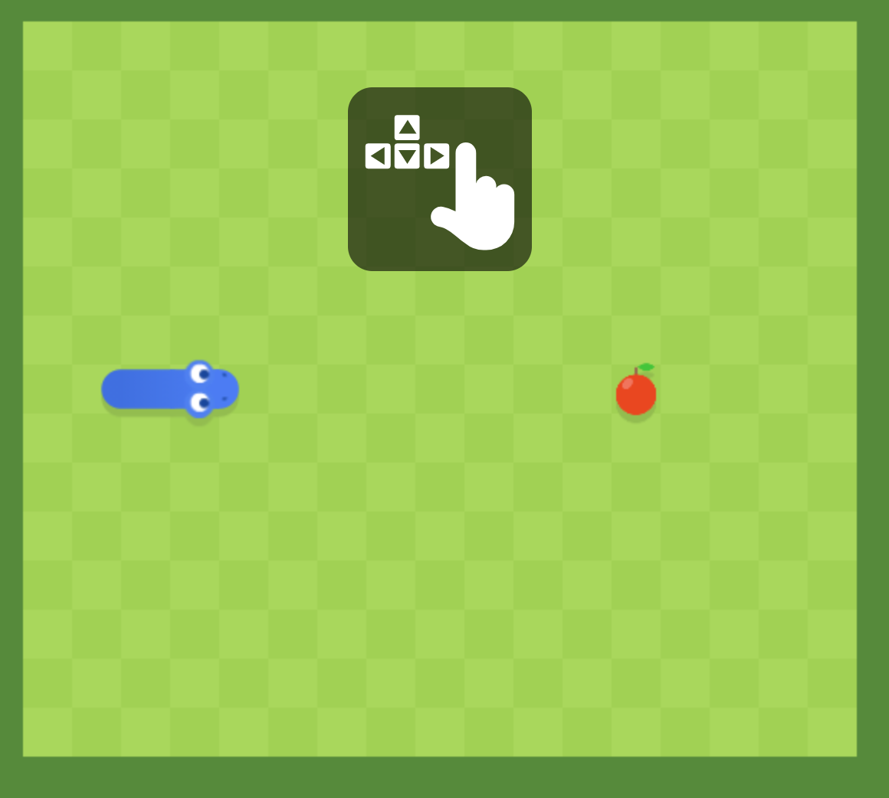

11. Deck.of.cards
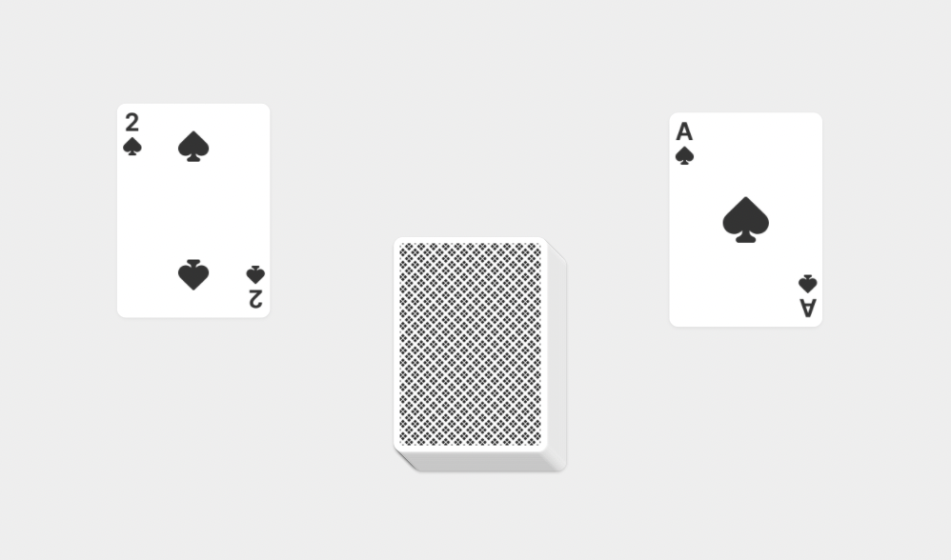

12. http://weavesilk.com/ (this works best if you share the link with each student so they can experiment on their own)

