Reading Quest
Online Games, Initiatives and Energizers*

Thank you to all of the organizations and people who generously shared these wonderful activities online. We stand on all of your shoulders!

Three keys to successful online fun activities:

- Slowly roll out each activity, at first choosing full group activities that don’t put any one person on the spot.
- Make sure each person knows that they count and they matter. We care if they are not participating or if they are not there.
- Make it your own and model each activity with full enthusiasm. Allow yourself to be silly. Your positive attitude will help build the group energy which is especially needed when online. Own it and have fun!

Why do teambuilding?

- Connection First: Studies show that learning is more effective after a safe, cooperative group culture has been created.
- Team Building Time: Team building activities create trust and a feeling of unity among participants and support learning in a variety of learning modalities. Students are more likely to interact, ask questions and take risks in class if they have already done so in their team building time.

Before you begin:

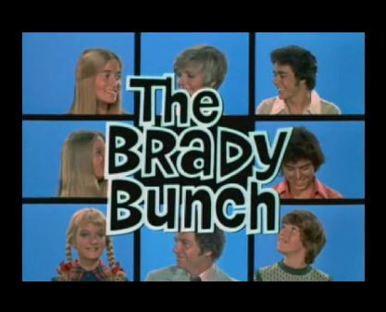
- Make sure everyone has gallery/grid view on
- Make sure everyone practices using the chat, both to everyone and privately
- Make sure everyone practices using mute and covering their window with a post it note or small square of paper
- Prepare your class list of names in Wheel of Names: https://wheelofnames.com/
Getting to Know Each Other & Teambuilding

- Post it note reveal:
Students all have a small piece of paper that they slide over their computer camera. The teacher asks a question and students “open their window” if it applies to them. Then you can let students start to ask the questions too.
Example:
Teacher: “Open your window if you are an early riser”
Then, whichever students are early risers, open their ‘window’ and sees which other students are also early risers
Teacher: “Open your window if you like to stay up late playing Minecraft.”
- Hot Seat: it’s a chance for students to get to know their teacher first and then each other. Start with the teacher in the Hot Seat Students take turns asking the teacher:
· a yes/no question
· a Who, what, where, when, why question
· For younger students, give a sentence starter for each one
For example:
For the yes/no question:
· Were you.....?
· Have you ever...?
· Did you ever...?
For the Who question:
· Who do you ?
For the What question:
· What is your…,?
· What did you….?
Then students can take turns being in the Hot Seat. It’s a great way to get to know each other. If you want, students can type their questions in the chat box first to the teacher privately if the teacher is concerned about questions being appropriate.
You can always pass on a question.

- Name Ball Toss/Group Juggle:
Type the students and teachers names into the chat box in ABC order. Say the name of the first person and throw an imaginary ball to them. They catch it and then throw it to the next person. After you’ve done one round, time it. Keep doing the name ball toss using the same order. Then try to improve your group time each time you do it. The class wins a field trip (virtual) each time they decrease their time. When you get down to one second per person then try throwing out a second ball a second or two after the first ball.
- Simon Says:
Kids stand up for this game and when they’ve made a mistake three times, they keep playing sitting down, as a ghost. It’s all about honesty. Do a lot of movements that cross the midline- as the class gets more comfortable with each other, you can get more crazy with your movements. (eg. swim, dance, become different animals) If any student tells another student that they are out, then the student who said that loses one life. You can play muted of course.
- Be the Leader:
Using Wheel of Names (https://wheelofnames.com/), spin to see which student is the guesser and needs to turn their back to the class. Students can pass if they are nervous at first to do either role. Everyone is on mute. Spin the wheel again to see who is the Leader. That student then starts doing actions that everyone follows. The guesser turns back to the screen and has three tries to guess who the leader is.
- Movement Memory:
Each person says their name and an adjective or verb that starts with the same letter as their name eg. Excited Eli, Rocking Rosie. As each person takes their turn, they repeat the earlier students name and adjectives and then add their own.

- Museum (also called Statues):
Played just like regular museum and when the guard turns their back, everyone moves slightly. You can imagine each turn is a dfferent floor of the museum (animal statues, sports statues etc.).
- Don’t Show, Just Tell:
Find an object from your home: describe it without showing it and everyone else guesses what you are describing as you hold it in your lap (use the spinner for who get to go- or type guesses in the chat box or raise hand or teacher calls on kids or popsicle stickers or a spinner) Students can take turns telling about their object too. This gives practice with speaking in complete sentences and using adjectives to describe objects.
- Show and Tell:
With homemade objects or objects from nature only. Make sure to take turns and to have just 2-3 students each day with a time limit. After each student shows their object, allow 1-2 comments or question.
- WHAT ARE YOU DOING?
1) Invite participants to stand or get ready to move at their seats.
2) Explain that you are going to act out a movement like climbing a mountain and you say, “i’m climbing a mountain.” Within 10 seconds,. a student then asks, What are you doing?
3) When you respond, you say something like, “I am doing needlepoint.”
4) Whomever asked you what you are doing, now mimes what you said.
5) Someone new asks them, “What are you doing?” (keeping in mind whoever asked them will have to mime that thing).
6) The more wild and fun the miming and the actions are and the more different the responses from the mimed actions, the more fun.

- Zoom In:
Zoom in on a picture you saved on your desktop and everyone takes turns guessing what it is. Then slowly get closer and closer. Encourage students to use adjectives to describe what they are seeing and not to just make guesses. You can get pictures from google images and unsplash.com
- ALL TOGETHER NOW- ALL AT ONCE:
One person says a classic character.
Example:
Chef. The next person says an emotion.
Example:
Angry. Everyone has to act it out all at once. An Angry Dentist - A Sad Fireman.
- ABC Emotions game:
Following ABC order each person says the next letter of the alphabet using a different emotion. Each student says the next letter of the alphabet with the chosen emotion. For example, if the emotion is fear, the first person says A, showing fear in their voice and face. The second person says B! again, showing emotion. This is easier to do once everyone really knows their ABC order of their own names and the order of the alphabet. For younger kids, it helps if the teacher holds up a card showing the next letter.
- Alphabet Blurt:
The goal is to say as many letters in order as we can as a group without anyone talking at the same time as someone else. All of us must take turns saying each letter as we go, and no one can speak except to say a letter. If anyone repeats a letter or says a letter at the same time as another member of the group, we must start again at 'A'. We try to get further in the alphabet each time. The group cannot decide on a pattern or go in any predetermined order.

- Inside Scavenger Hunt:
This has endless options. You can ask kids to find something with a particular use, eg. something you drink out of or something blue. OR something in your house that you are proud of. Or something that starts with the letter L, or something you made, or something that has 2 syllables, etc... You can allow different students to share each time you play.
You can do a scavenger hunt as a connecting activity:
· FIND… (just one and then share…..)
· Something you can’t live without
· Something that makes you laugh
· Something that smells good
· Something that reminds you of someone else A book you love
· Something that helps you get up in the morning
· Something no one else will have
- Animal Charades:
Privately chat to the person who is it what their animal is. This can also be done with any type of charades. This can be done in two teams- Both teams take turns guessing and use the chat box to guess or hand raising. If someone from the team who is acting guesses it, then that team gets a point.
- Storyteller
Following ABC order, each person says one sentence at a time as the group tells a story. Students practice listening to each other carefully and following along with the story so it makes sense.
Level 2: each person says 1 word at a time.
- 3 headed expert:
3 students at a time are the “experts” who answer questions one word at a time. The rest of the class poses questions such as, ‘Why is the sky blue? or ‘Why do dogs bark?’ The 3 headed expert always answers by first repeating the first part of the questions, eg. “The sky is blue because...”and then they each answer, one word at a time, acting like they are the experts on every subject.

- Silly Face with screen shots:
kids make a funny face one at a time, pin them so their face is large and take a screen shot of each face.
- I spy or In Plain Sight:
The teachers turns off their video while they place a clothespin (or a similar everyday object) somewhere on their bookshelf right behind where they are sitting so that it is a bit hard to see on the screen. The students all turn off their videos. When each student spots the object, they quietly turn on their video. The second round, everyone keeps their video on at the start and then turns it off when they see the object.
- Read my Lips:
People take turns saying a common phrase with no voice and everyone else types in the chat box what they think was being said.
- Rock Paper Scissors:
Play as usual or play to find a final winner.
- ABC Games:
I’m going on a picnic and I’m going to bring (the first person brings something that starts with an A, the second person brings that item and something that starts with a B etc.)
- Cookie Sheet Magnet Game:
Either play like Hangman or start to write a word, letter by letter and the students try to guess what word is being written but typing in the chat box
- Freeze Dance:
Play different songs and everyone dances and when it stops, everyone freezes.
- The Wave:
figure out how to make the wave with the whole class.

- Alphabet Four Square:
Use a white board on zoom (give a different letter each time)
Name | Place
Animal | Thing

- Goats in the Grass:
an animal and a place for each letter -Ants in Antarctica, Bees in the bath
- Alien, Tiger, Cow: everyone stands up and becomes either an A, T or C. They all turn around and then turn back at the same time. The goal is to try to get everyone with the same letter at the same time.
- Why Were You Late
1 person is chosen to be the one who is late (send them to the waiting room) The teacher is the boss first. The kids all decide with the teacher why the person was late and what kind of work the person does. Then, when the worker comes in late, the other kids pantomime to help him guess his answers.
- Animal Yoga:
Kids each share their favorite animal as part of an introductory name game activity and then incorporate those animals into the yoga poses.
- Juggling:
Tossing a ball (or balled up sock) with oneself- toss up and catch, toss from one hand to the other. Once they mastered that - toss and clap, then toss and spin (very advanced), toss it high, etc.. This could also lead into juggling. This was drawn from eurythmy (from Waldorf).
- Broken Robot
1 person is the robot who is blindfolded. Everyone else chats on chat box as each person chooses one word that will be the only word they can say during the activity. Give a task to the group without the blindfolded person hearing (for example: get the person to touch something soft) Each person in the group says their word when needed to guide the person to complete the task.
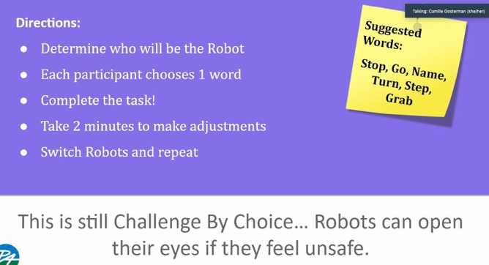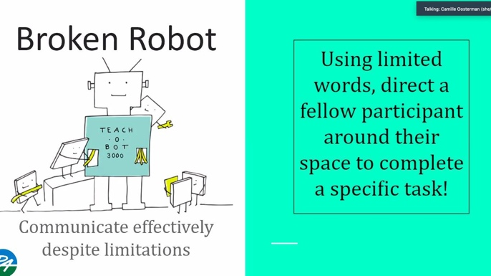
- Brain Teasers:
https://icebreakerideas.com/brain-teasers/ https://parade.com/1025639/marynliles/brain-teasers/ https://www.rd.com/list/brain-teasers-for-kids/
- Appreciations:
Choose one person, everyone else types into the chat 1-2 words that describe something they like about that person or take turns saying your appreciation. Or you can do appreciations for anyone in the group who showed courage or kindness etc.
- What’s My Number:
Fold an 8.5 x 11 paper in half horizontally. Write your name on the top half of a paper and a set of 4 or 5 numbers on the bottom half of the paper. Then each person shows theirs, one at a time, and everyone guesses why those numbers.

- Ticket to a party:
Everyone types into the chat box what they want to bring and you keep telling them yes, or no. Everyone tries to guess what the rule is. For example, you can’t bring soda, but you can bring kool aid. You can’t bring jam but you can bring butter. You can’t bring cans, but you can bring bottles or a glass. Secret: The rule is you can bring anything with double consonants or two vowels walking.
- Random-cards.com:
Each person takes a turn saying what number or card will NOT turn up next. See how many cards you can turn over successfully.
- Gotcha!:
Everyone stands as far as they can from the computer. The person who is it, ducks their head so they can’t see the screen and everyone tries to quickly move toward the screen. If you’re seen, the person says your name and ‘Gotcha’ and you have to move back to the beginning. The winner is any person who can get to their computer first and type ‘Gotcha!’ in the chat box without being seen by the person who’s it.
- Change 1, 2 or 3 things:
Everyone looks carefully at the chosen model. Then the model turns off their video and change 1, 2 or 3 things about their appearance before turning their video back on. Tell the participants how many changes were made.
- Andy Goldsworthy Art: invite students to spend time outside and create artwork using only objects found in nature. Take a photo and send it to the teacher.

- Escape Rooms 1-2 people or 1-2 teams: https://www.enchambered.com/puzzles/alone-together/ https://ditchthattextbook.com/30-digital-escape-rooms-plus-tips-and-tools-for-crea ting-your-own/?fbclid=IwAR2aCpU6iJMs2LYLyYVriyKhS0LDlGQ99p-Tkxw-5tiz 9aCKDZuwK1adiM0
- Pass the Object:
Everyone has the same object and takes turns saying something else it is. eg Pass a hairbrush, one person uses it as a microphone, one person uses it as a race baton etc.
- Shake Down:
Counting down from 8 Everyone stands up with space for moving both arms. Put their right hand in the air and shake it vigorously, while counting down from 8 to 1. Then their left hand, then the right foot and the left foot. Then you start again from 7 and go on all the way down to 1 shake on each limb. Note that as you get to the low numbers, the action of shaking gets more animated and fast. Keep it moving along for maximum fun and energy.
- Vocal Projection:
Suggestions for what they are saying: (it might help if one stands on a chair sometimes)
· a person in a small boat asking for directions from a person in a large boat
· a person lost in an underground tunnel trying to communicate with someone above ground
· two people in a blizzard trying to find food and shelter
· a person in an upstairs window calling to a friend in the street.
· two people talking on cell phones that have bad reception
· two people who are both very old and hard of hearing, trying to catch up on each other’s lives
· a job foreman giving directions to a construction worker in a big bulldozer
· two people at a rock concert trying to have a conversation

- One sentence said different ways:
Everyone says the same sentence but in a different way each time (happy, sad, angry, nervous, excited) or give out the emotions to different people and have them each say the sentence in the way that matches their slip of paper. Or they could say it as a news announcer, or a clown etc…
Examples of sentences:
I went for a walk the other day and fell down.
I have to walk seven blocks to catch the bus.
Last night my parrot told me to leave the house.
My bathtub is so big I can swim in it.
Last night my dog bit me.
My mother wears a different color wig each day.
I climbed a tree yesterday and stayed there all night.
Last week I decided to take driving lessons.

- Group work:
A group of students work together to become a car, a washing machine etc..
- Target Word:
Show the audience a target word, tell one person in the pair the target word. Then that person tries to get their partner to say that word while acting in front of the group.
- Environmental Sound effects:
Small groups come up and the teacher whispers an environment to them. They have to work together to make the sounds of that place and the audience guesses where they are. It might be good if the audience closes their eyes and raise their hands to guess after 30 seconds of sounds. (rain forest, train station, jungle, harbor, busy street, playground)
- Sound Effect scenes:
One person acts out a scene and their partner makes the sound effects. For example, you are getting into your car, you are turning it on, driving around…
- Gibberish game:
Three or two people get up and you give them a scene to act out, but they can only speak in gibberish.
Level 2: Interpreter: you give them a scene and both are aliens who don’t understand each other. Each of them has a translator who speaks alien and english and can translate. Translators speak in first person.
- Commercials:
Do commercials with props or any basic object (have the group brainstorm the basic things that must be in each commercial- where to get it, why you should buy it etc..)
- Three Word Skits:
Give each group three random words and they have to do a scene where each person (there are 3 in a group) works that word into the scene so that it makes sense. (frog, telephone, basketball) The audience has to guess which three words they were given.
- Flippity.net (get Flippity add-on for google sheets)
· You can make spinners and label each one as you wish
· Bingo
· Board games
· Scavenger hunt
· Connect 4
- FIREWORK DISASTER:
All together first. Make a noise that sounds like a firework going off. Then add movements to the noise. Then one by one ask each student the name, colour and cost of the firework. This is a nice and noisy icebreaker.
- JUSTIFY YOURSELF:
To play this you ask the students to jump around, up down, touch the floor, and spin about. Then shout freeze.Go to each student in turn and ask them to justify their position. I.e. If they are standing there with their arms in the air they may be playing netball. So they may say something like: ‘Hey I have the ball, quick I will pass it to you, ready…’ Think of it as a solo freeze tag
- PROPS:
Children are asked to go and find a prop from their house. First one back gets a point (if you have them in teams) Each student must use the prop for something other than it is by incorporating it into a scene.
- RAP:
Players have to make up a ‘Rap’ about...Shoes, fruit & vegetables, television, school, etc. You could use the Zoom breakout rooms to do this so they can work in teams or groups.
- WORLD’S WORST:
Each player must act out the world’s worst person to be… a policeman, a teacher, a pilot, a child in a nativity, a Shop assistant, An Air hostess, a Car Sales person, a flight attendant, a Swimming instructor... Each student must raise their hand when they have an idea.
- Won’t You Be My Ducky Wucky:
One person at a time tries to make the others laugh by saying, “Won’t You Be My Ducky Wucky and give me a smile.”
- Can you get to Z?:
One person tries to say the whole alphabet before cracking up as the other people try to get that person to laugh.
- HISTORY LESSON:
Each player has to go get two objects and then give a history lesson as to how one evolved from the other.
- MACHINE:
Each player makes a sound and a movement, when their number is called, once everyone is involved you raise your hand to indicate the machine is increasing in speed, when you raise both hands the machine explodes. Go round to each player to discover what their machine was making and why.

- Videos of Online Games and Reader’s Theater
https://www.playmeo.com/activities/: online games https://teachers.net/lessons/posts/1129.html: Reader’s Theater https://www.youtube.com/watch?v=6thusSu-Qt4: zoom games https://www.youtube.com/watch?v=KnWUvpMQOpw: zoom game
http://www.aaronshep.com/rt/index.html : Reader’s Theater https://www.youtube.com/watch?v=6ZHuCkekyrE: zoom Games
http://web.archive.org/web/20051125105334/
http://hometown.aol.com/rcswallo w/TruePigs.html: The True Story of the Three Little Kids
https://www.fortetheatrecompany.org/daily-theatre-games: Theater Games
http://www.fictionteachers.com/classroomtheater/andso.html: Reader’s Theater
http://web.archive.org/web/20051121163638/http://users.aol.com/rcswallow/DinosaurLand.html : Reader’s Theater

- Debrief:
An initiative is only as good as its debrief! A well-thought out debrief is integral and therefore, mandatory. Debriefing is the process that makes the activity relevant.
A few solid debrief kickoff questions:
· What are some of the things the process sparked for you?
· What are some behaviors or dynamics you noticed when…?
· I’d like to hear some of your thoughts on how the process unfolded for you.
What are some of your observations about your team’s process?
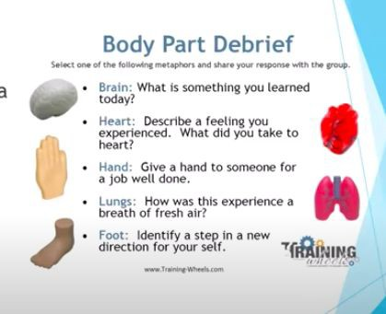

Active and Engaging Education Technology

Zoom Support – Free webinars and other support for how to use Zoom for online learning https://www.mural.co/ - Mural is a digital workspace for collaboration – perhaps are preferred application for teacher training

Loom – A free video tool for asynchronous recording your screen and other audio

Edpuzzle - Use or create videos for teaching, including accountability measures, quiz tools, and more

Pear Deck - Google Slides add-on to make presentations interactive and engaging Menti (participants)/Mentimeter (facilitators) – Interactive slide creator to poll students, create word clouds, quizzes, and more

Flipgrid – Video prompt & response app

Kahoot! – Make your own quizzes and trivia-style competitive games
Project Adventure – Leading edge on-line experiential education expertise for direct service student program, teacher training, and a broad range of consultation services https://workshops.pa.org/

Playmeo – Online video-supported adventure activities from a Project Adventure alumnus

FUNdoing – Teambuilding activities, SEL resources, and printable tools

Training Wheels – Online activities
https://training-wheels.com/trainings-workshops/staff-training/

Sample Reader's Theatre
Tacky the Penguin by Helen Lester- 15 parts

5 narrators
5 penguins
4 hunters

Narrator 1: There once lived a penguin.
Narrator 2: His home was a nice icy land he shared with his companions.
Narrator 3: His companions were named Goodly, Lovely, Angel, Neatly, and Perfect.
Narrator 4: The penguin's name was Tacky. Tacky was an odd bird.
Narrator 5: Every day Goodly, Lovely, Angel, Neatly, and Perfect greeted each other politely.
Goodly: Hi! Lovely: Hi! Angel: Hi! Neatly: Hi! Perfect: Hi!
Narrator 1: Tacky greeted them with a hearty slap and a loud
Tacky: WHAT'S HAPPENING?!?!?!
Narrator 2: Goodly, Lovely, Neatly, Angel, and Perfect always marched Goodly: 1-2-3-4
Lovely: 1-2-3-4
Neatly: 1-2-3-4
Angel: 1-2-3-4
Perfect: 1-2-3-4
Narrator 3: Tacky always marched 1-2-3 4-2 3-6-0 2 ½ 0.
Narrator 4: His companions were graceful divers.
Narrator 5: Tacky liked to do splashy cannonballs.
Narrator 1: Goodly, Lovely, Angel, Neatly and Perfect always sang songs like "Sunrise on the Iceberg."
Narrator 2: Tacky always sang songs like "How Many Toes Does a Fish Have?" Tacky was an odd bird!
Narrator 3: One day the penguins heard the thump, thump, thump of feet in the distance.
Narrator 4: This could only mean one thing.
Narrator 5: Hunters had come!
Narrator 1: They came with maps and traps and rocks and locks, and they were rough and tough.
Narrator 2: As the thump...thump...thump drew closer, the penguins could hear growly voices chanting,
Hunter 1: We're gonna catch some pretty penguins,
Hunter 2: And we'll march them with a switch,
Hunter 3: And we'll sell them for a dollar,
Hunter 4: And get rich, rich, RICH!
Narrator 3: Goodly, Lovely, Angel, Neatly, and Perfect ran away in fright. Narrator 4: They hid behind a block of ice.
Narrator 5: Tacky stood alone.
Narrator 1: The hunters marched right up to him, chanting,
Hunter 1: We're gonna catch some pretty penguins,
Hunter 2: And we'll march them with a switch,
Hunter 3: And we'll sell them for a dollar,
Hunter 4: And get rich, rich, RICH!
Tacky: What's happening?
ALL Hunters: We are hunting for penguins. That is what's happening." Tacky: PENGUINS? Do you mean those birds that march neatly in a row? 1-23 4-2 3-6-0 2 ½ 0
Narrator 2: The hunters looked puzzled.
Tacky: Do you mean those birds that dive so gracefully?
Narrator 3: And he did a splashy cannonball. The hunters looked wet. Tacky: Do you mean those birds that sing such pretty songs?
Narrator 4: Tacky began to sing and from behind the block of ice came the voices of his companions, all singing as loudly and dreadfully as they could.
Goodly: How many toes does a fish have?
Lovely: And how many wings on a cow? Angel: I wonder, yup
Neatly: I wonder!
Narrator 5: The hunters could not stand the horrible singing.
Narrator 1: This could not be the land of the pretty penguins.
Narrator 2: They ran away with their hands clasped tightly over their ears,
Narrator 3: leaving behind maps and traps and rocks and locks,
Narrator 4: and not looking at all rough and tough.
Narrator 5: Goodly, Lovely, Angel, Neatly, and Perfect hugged Tacky. Tacky was an odd bird but a very nice bird to have around.

Puzzles
