Evaluation of the 2017 ‘Reading is Magic’ Summer Camp 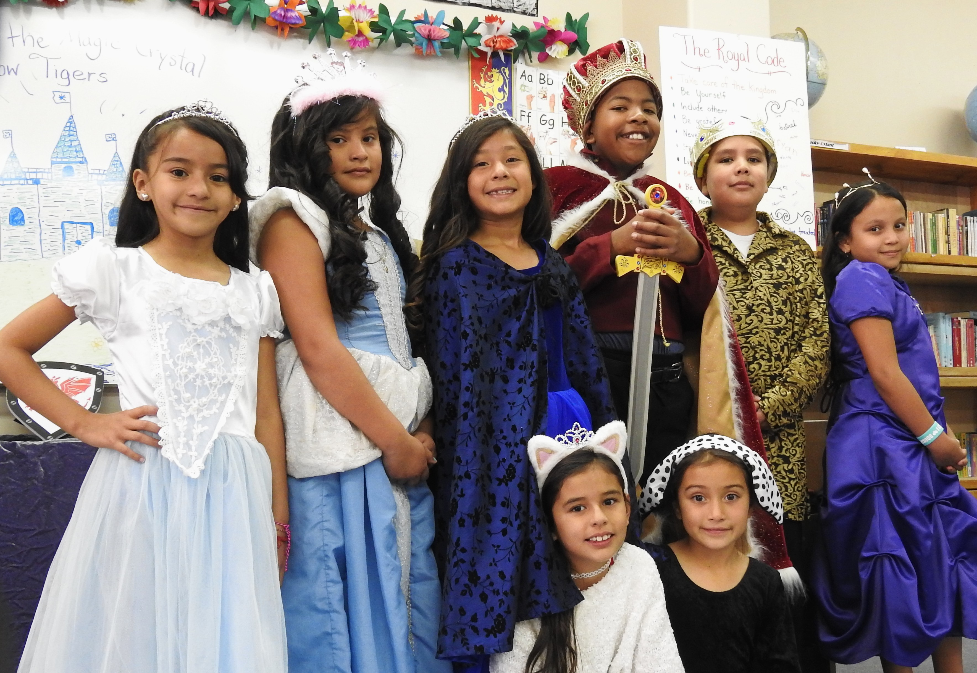

In the period from July 10, 2017 to August 4, 2017 Rayna Dineen, Executive Director of Reading Quest, in partnership with Santa Fe School for the Arts & Sciences, engaged 40 public school students entering grades 3 - 5 in an intensive literacy intervention. All of the students who were referred to the camp were identified by their teachers as needing serious remediation in reading. Students were referred from 11 different schools. Many of these students were 1-2 years, or more, behind in reading. Fourteen of the students had been retained, and two more were in the process of being retained. Fifteen of the students already had IEP's, and others were in the process of being referred for an IEP. Ten of the students were English Language Learners.
There were two two-week sessions with 20 students in each session. The sessions were equally divided between boys and girls.

The summer camp - called ‘Reading is Magic’- created an individualized reading program for each child that was supported by a wide range of hands-on activities and intensive phonics training. Each day the students learned new phonics rules and tricks and gained confidence in reading. They read aloud to teachers, played reading computer games and phonics-based active games and board games, such as Reading Baseball, Word Jousting, and the Nitro Reading Road Race Game. Most of the activities and games used in the camp were games which could easily be adjusted for different student needs and reading levels. They sang songs about reading rules, used American Sign Language to learn the short vowel sounds, and wrote stories and plays. The camp created a motivating theme for the two weeks as each student worked their way through the levels of the ‘Royal Road’ and earned points by working hard in every activity to eventually become a knight, a princess, or a prince. Students earned flags, shields, swords, and crowns along the way. Each day was filled with fun reading-related activities and the students also completed homework that addressed their specific reading needs. Each student was sent home with books to read over the summer and Rayna is communicating with their schools regarding their progress.
Before the camp began, the participants were tested to determine their beginning level of reading fluency. On the last two days of the camp participants were tested again to measure their growth during the two weeks. Students were tested using the Oral Reading Assessment (ORA) developed by Edward Fry, PhD. The test involved students reading paragraphs of increasing difficulty and resulted in a score expressed as a grade level.

The average growth for all students during the two-week intervention was just a little more than one year (1.05).
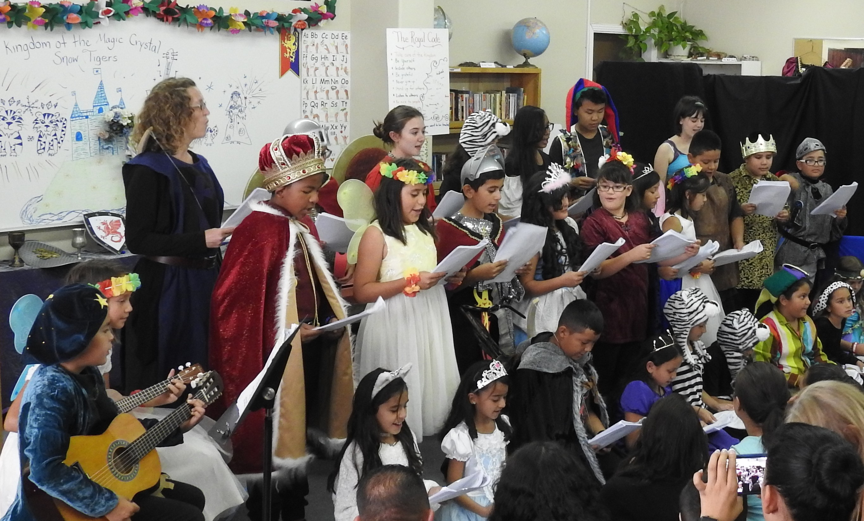

Reading is Magic Summer Camp 2017
Average Student Growth in Oral Reading (fluency and accuracy)

Oral Reading Growth Average: 1.05 Years

