Literacy Support Center
www.readingquestcenter.org
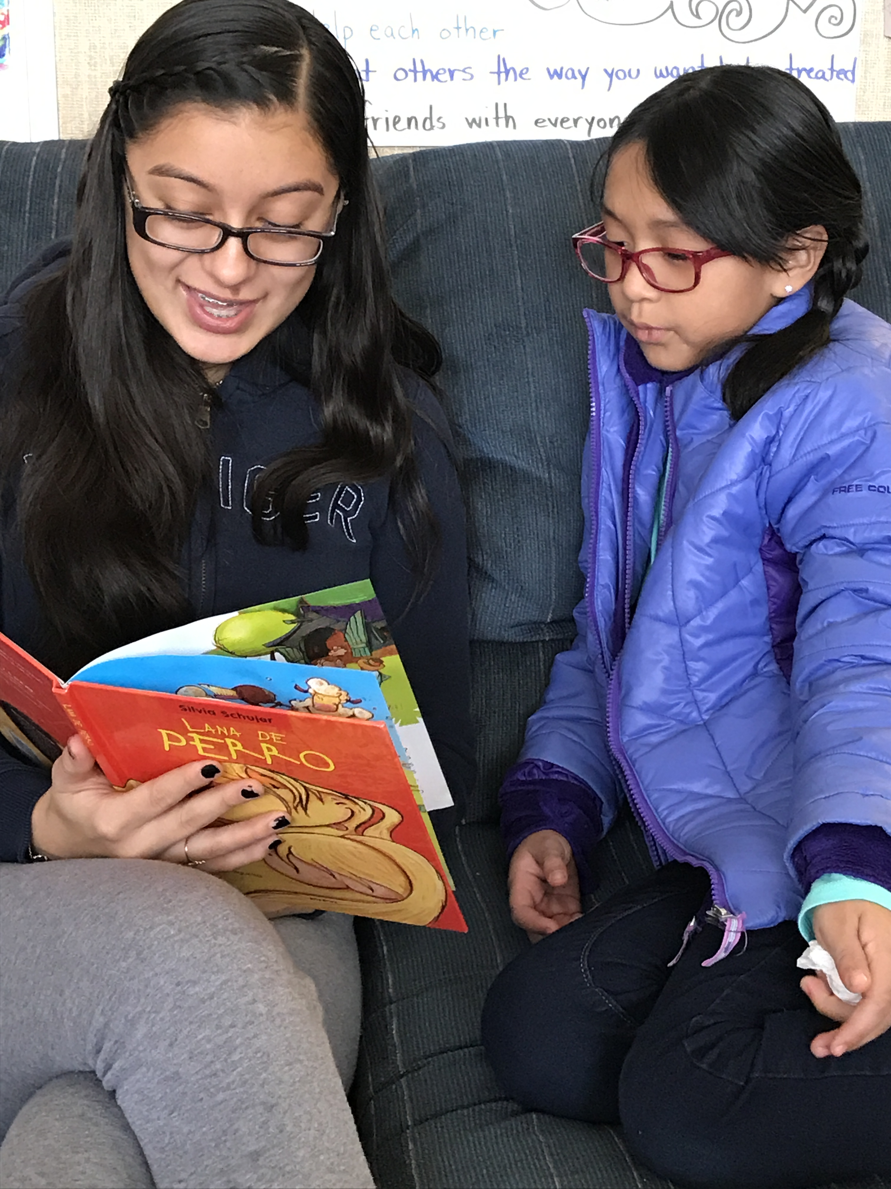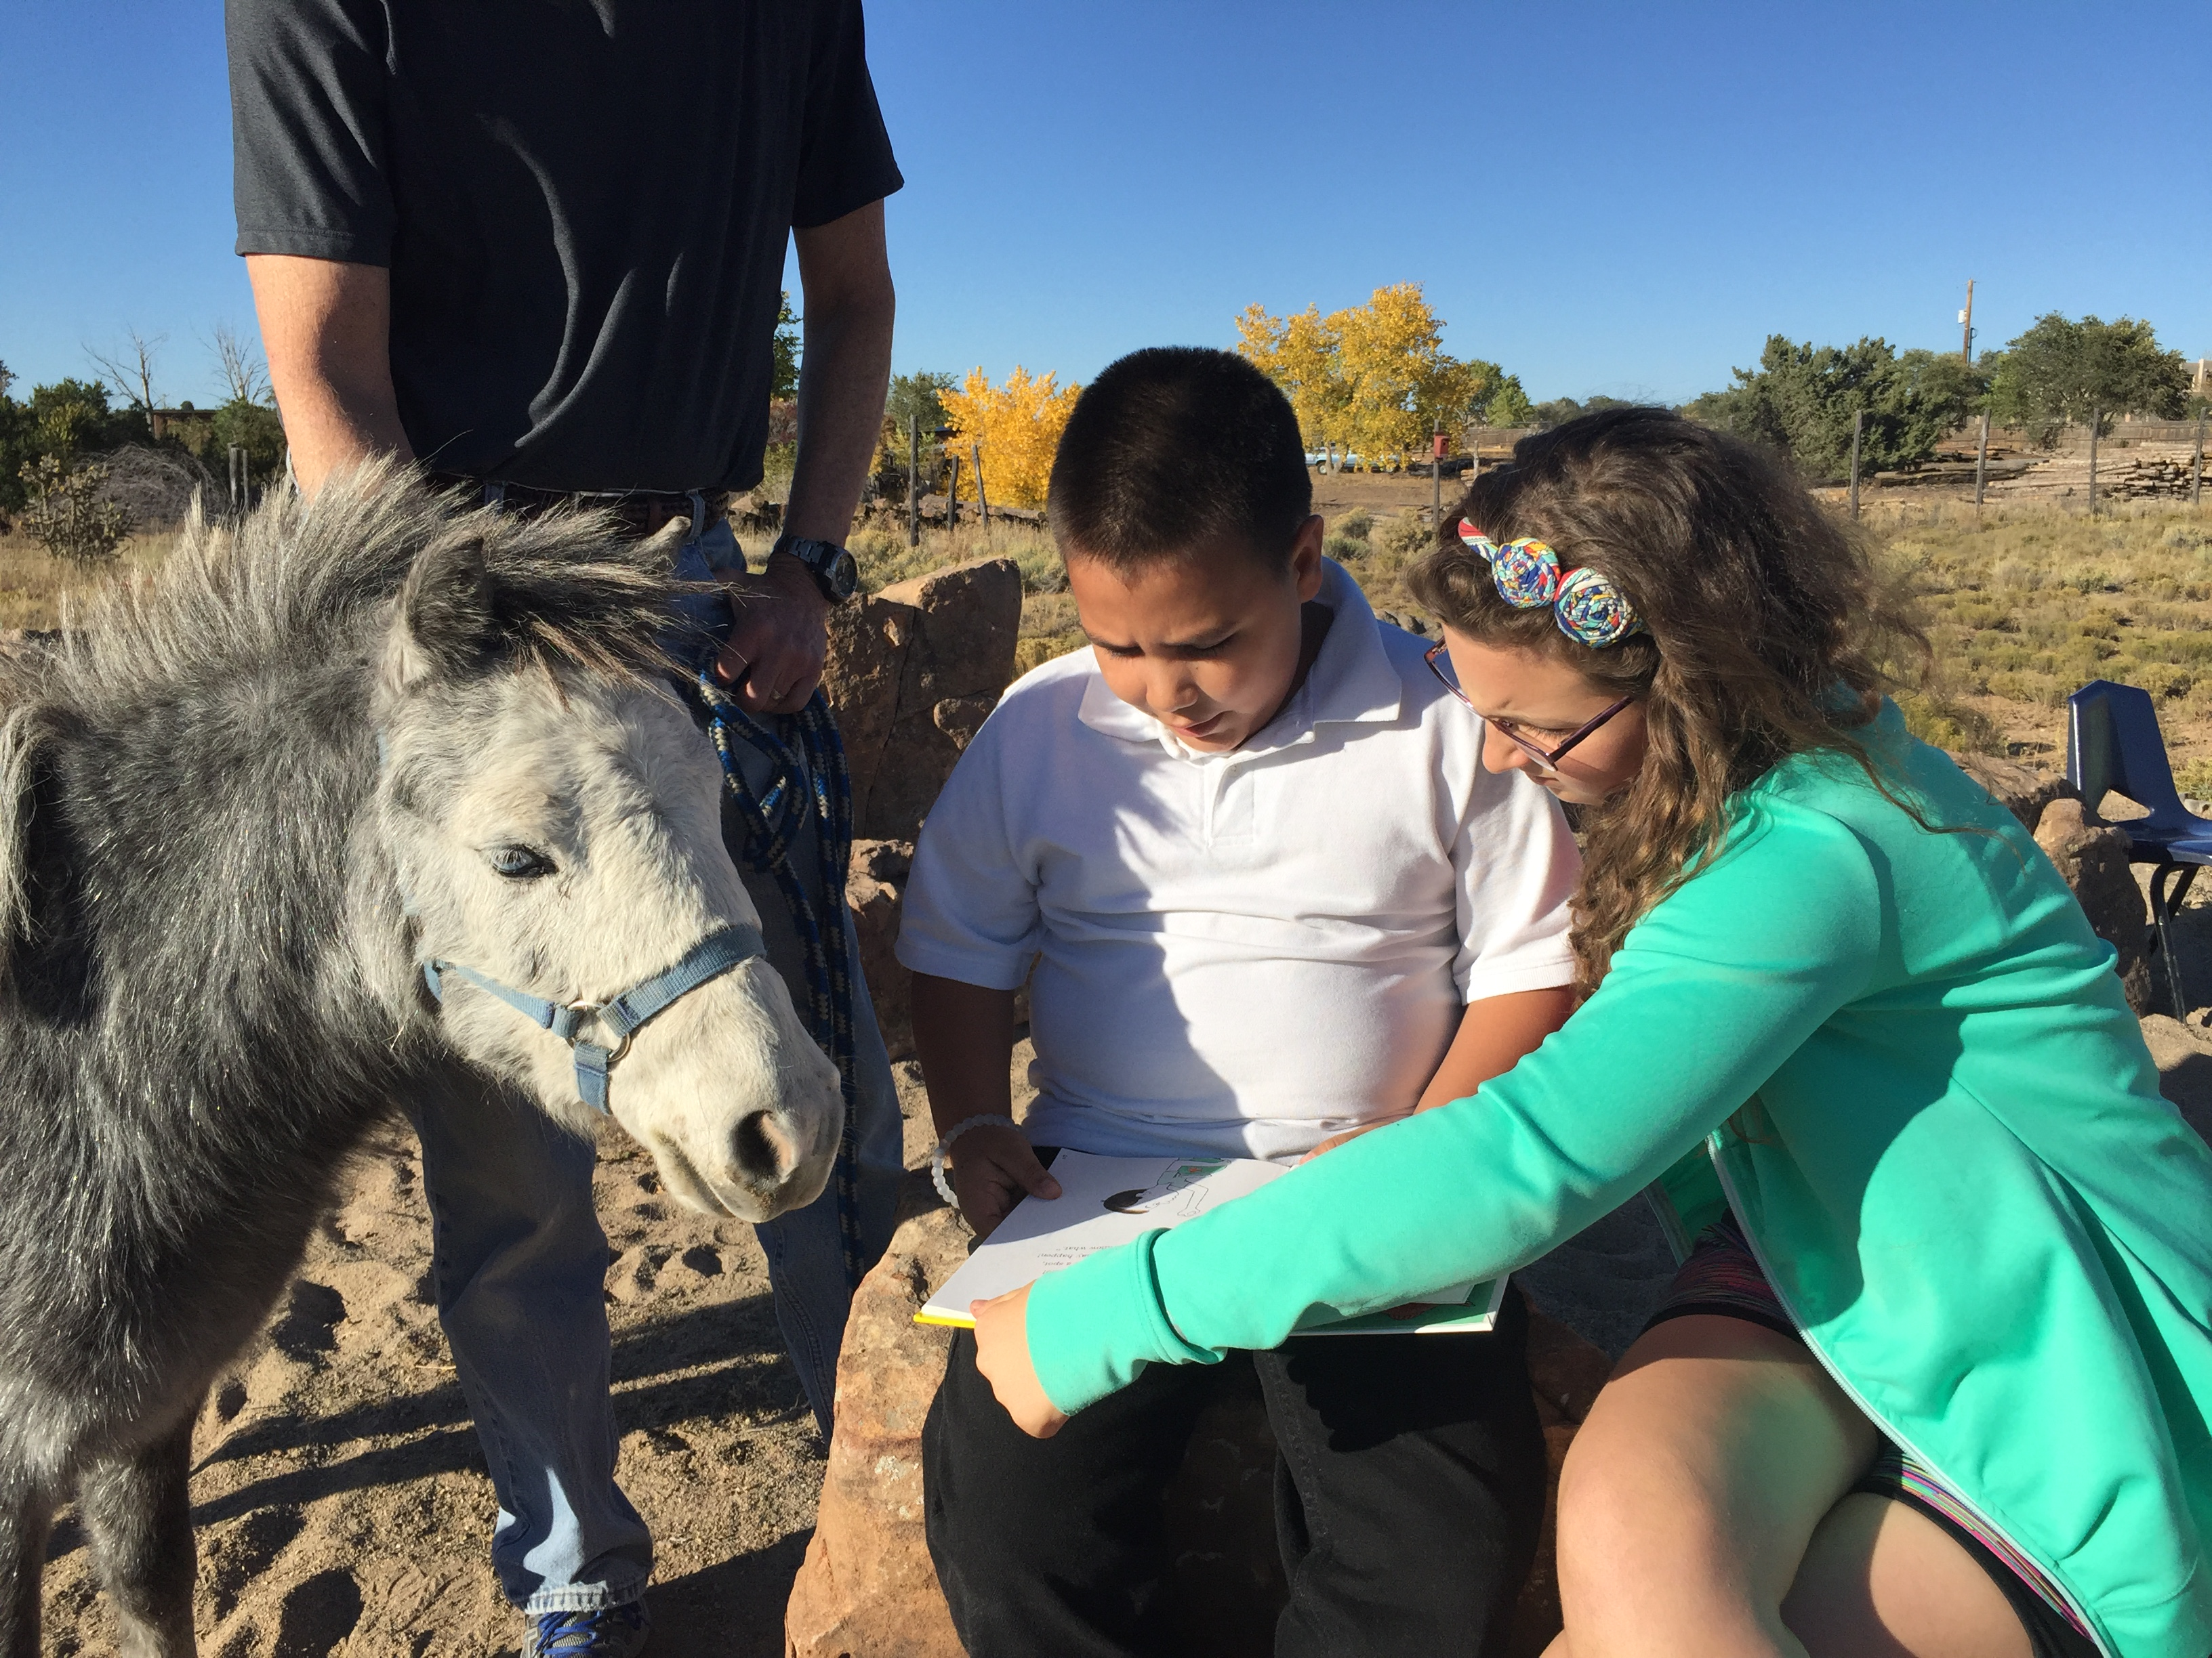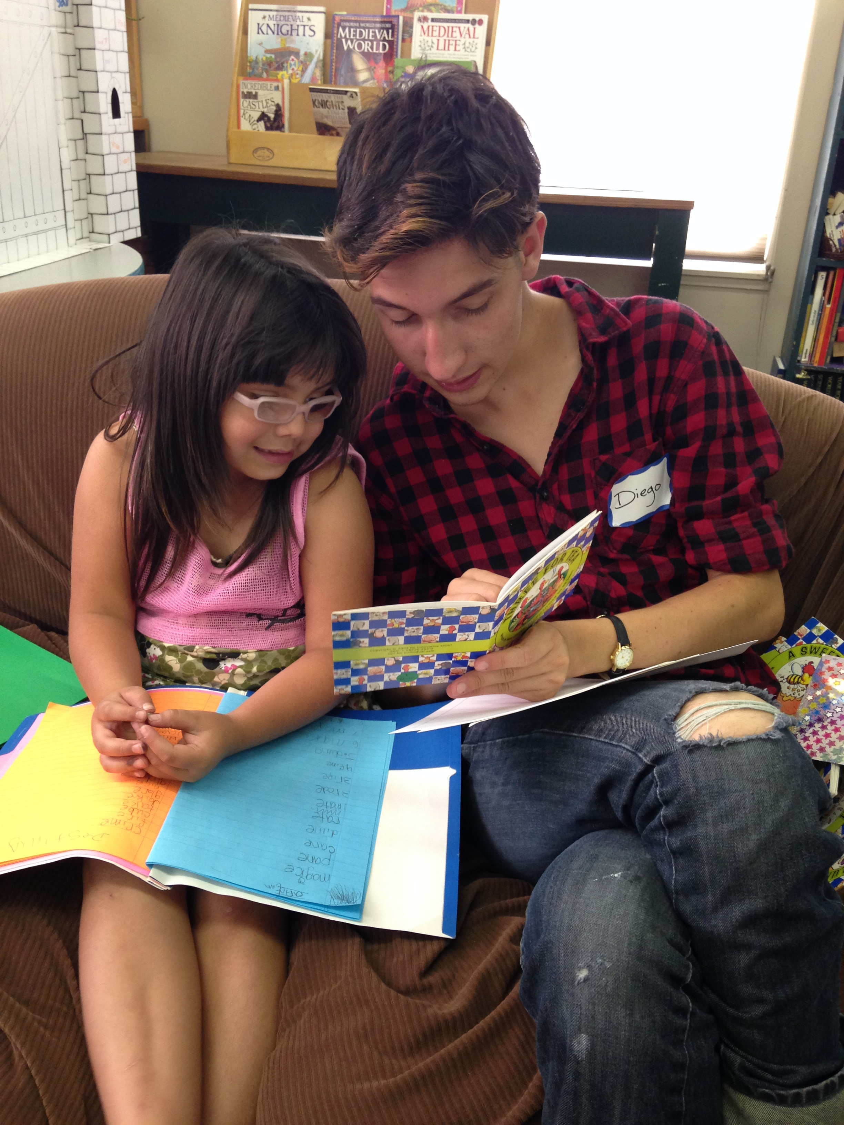
Reading Support Workshop
for Parents
For parents of children in grades K-3 who are reading behind grade level

Sunday, March 11
1:00- 3:00

RSVP requested by March 5
505-920-9709

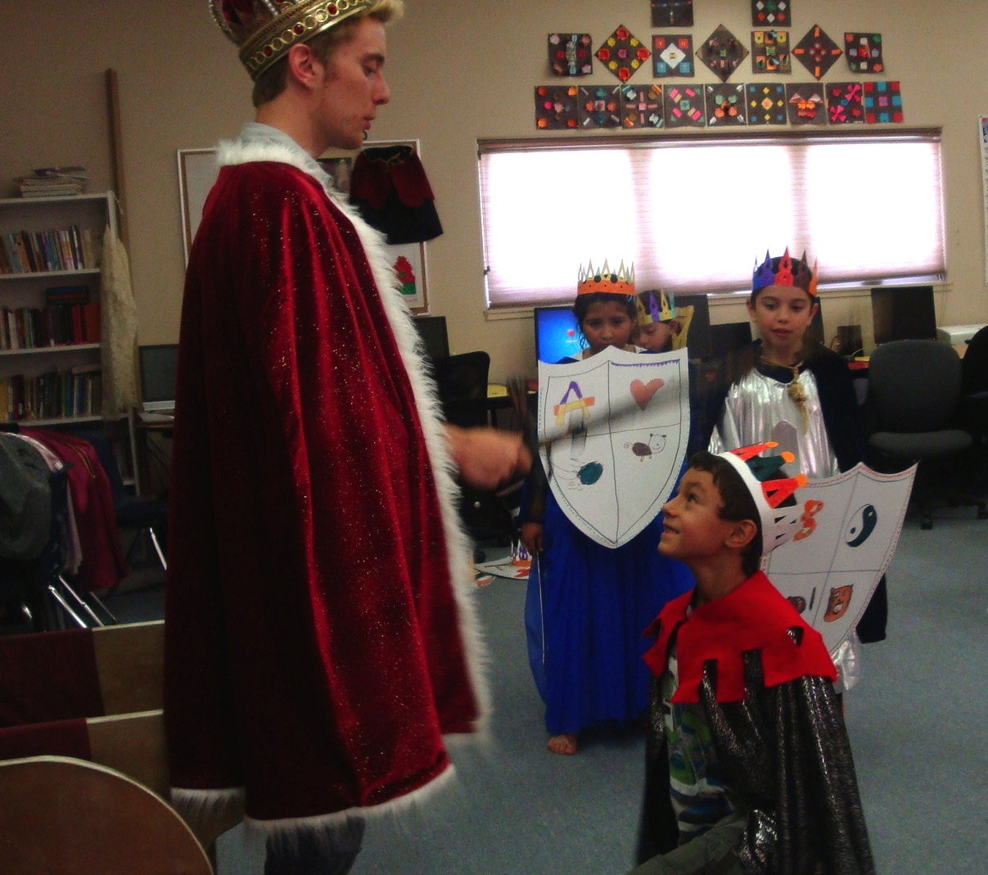
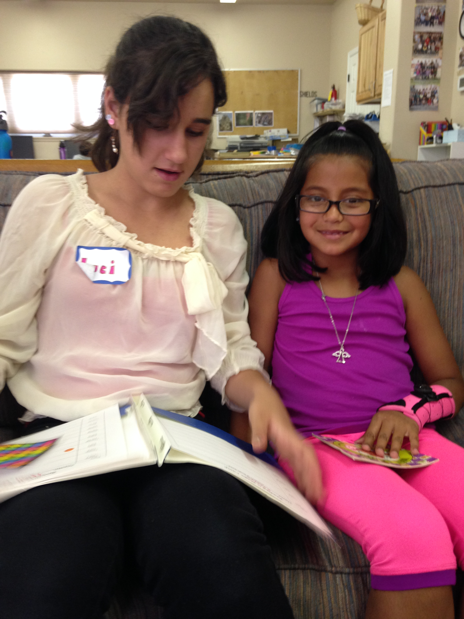
This workshop will provide concrete support and strategies for parents who want to support their child’s reading. We will share the rules of reading, phonics 101 and reading resources.

Reading Quest is a local, non-profit organization whose mission is to support literacy for the children of Santa Fe.

We provide year-round free and sliding scale reading tutoring; free intensive ‘Reading is Magic’ summer camps in collaboration with Santa Fe School for the Arts & Sciences; training and coaching for parents and teens; and professional development for teachers.

Contact Information

www.readingquestcenter.org

Readingquestcenter@
gmail.com

Director, Rayna Dineen
505-920-9709
To Register

Please call 505-920-9709 or email readingquestcenter@
gmail.com for location and workshop details.

There is no charge for this workshop but tax- deductible donations are greatly appreciated!

